Article Title

Fistname Lastname^{1,2}, Fistname Lastname^{2,*}, and Fistname Lastname³
¹Affiliation 1, ORCID: 0000-0000-0000-0000
² Affiliation 2 ORCID: 0000-0000-0000-0000
*Corresponding author: Firstname Lastname Suryanto; Email: email@gmail.com

Abstract
A single paragraph of about 150-250 words maximum. Any abbreviation defined in the Abstract needs to be redefined upon first mention in the text. Please refrain from citing references in the Abstract, whenever possible; however, if cited, put in the reference details. For scientific articles, the Abstract should include an introduction, methodology, research findings, the conclusions which can be drawn from these results, and why this research matters. For non-scientific articles, the Abstract should provide an overview of the wider academic field, the gap in that field which the study fills (or error the study addresses), and the relevance of the research for the academic community

Keywords: keyword 1, keyword 2, keyword 3 (minimum 3 keywords are required, separated by comma (,); lower case; upper case only for proper nouns)
- Introduction
The main text is extended by printing 11 letter. References to literature in the text should be in the form [2] or [2, 3, 5]. All abbreviations in the text must be deciphered at the first mention.
The headings in the article are formatted as follows:
First level: Title case and Bold
1. First level heading
Second level: Sentence case and bold
1.1. Second level heading
Third level: Sentence case and Italic
1.1.1. Second level heading
Lists are arranged as follows:
- First level.
  - Second level.
Third level.
- First level.
- First level.
- Methods and Equipment
  - Methods
    - Subsubsection
All the tables are full of the normal number of the Arabic numerals. All table content must be editable, including formula and equation. Sources for all tables must be provided by the author; even if source is author’s own, use phrase such as ‘Author’s own work’. Table titles should go above the table. Title case, in bold, with the legend in sentence case and a period mark at the end. An example of table design below.
Table 1: Title of the table.
1 | 2 | 3
4 | 5 | 6
Links to tables in the text are formatted as Table 1 or Table 1 and 2 or (Tables 1 & 2within parenthesis).
- Results
Figures should be submitted separately, where possible, as high-resolution files to ensure good quality visuals online. Send 1200 dpi for line art, 600 dpi for grayscale and 300 dpi for color, at correct size, as a PGN or JPEG image. Sources for all figures/illustrations/photographs must be provided by the author; even if source is author’s own, use phrase such as ‘Author’s own work’.
If you are submitting high resolution images for figures in a separate document, make sure the individual images are clearly labelled, and the Figure title is included in the text to indicate where you wish the image to be placed in the PDF.
Links to figures in the text are formatted as Table 1 or Table 1 and 2 or (Tables 1 & 2within parenthesis).
Figure titles should go below the Figure. Title case, in bold, with legend in sentence case and a period mark at the end. Examples of tables design below.
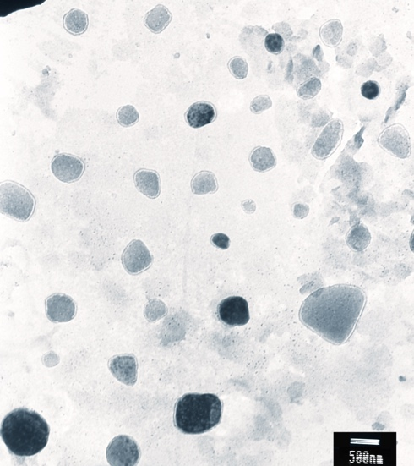 | 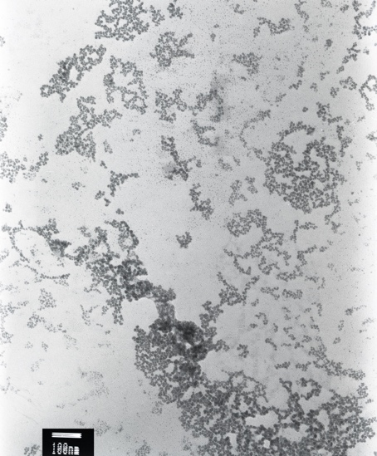
A | B
Figure 1: Figure title
- Discussion
Use UK or US spelling (with `ize` variant). This means that words with `ise`, `isation`, etc. will be spelt with `z` (e.g., ` recognize `, `cilivilize`, etc.).
For UK Spelling – follow Oxford Dictionary (https://en.oxforddictionaries.com).
For US Spelling – follow Merriam Webster (https://www.merriam-webster.com).
Hyphenation is put according to the dictionary.
Data style for UK Spelling: 14 March 2018.
Data style for US Spelling: March 14, 2018.
The time period is formatted as 2016-2017 (do not truncate); twentieth century, but 1980s. However, remember to hyphenate if referring to an object eg: nineteenth-century literature. s
An em dash is used for ranges, words of equal weight, phrases in brackets (with a space), theories and equations based on the names of two people, etc. For example, 10-12 kg, Noth-South border, Adams-Williamson equation.
An em dash is used for parenthesized phrases and setting off a particular phrase.
Use a comma after e.g. and i.e. in parenthesis. However, in the main text, use `that is` and `for example`, follow by a comma.
Oxford/serial commas: NO serial commas; can be used in long sentences if required for clarity.
The comma when writing thousands is used for 5 digits and above, for example, 1000 but 10,000.
Equations should be displayed on a separate line and must be submitted in an editable format. If they are numbered, then it should be in the format: (1), (2), (3). For example,
$ρ ∂h/∂τ = -div( ⃗q) + ω$. (1)
Only those formulas that are referenced in the text should be numbered.
Numbers 1-9 in the text are written as one, two, three, etc. Numbers 10 and above in the text are written as 10, 11, 12, etc. For exact measurements, use only figures (34 km, 4%). Fractions are written entirely according to the text (half, three quarters, one third), but are written in digis in tables.
- Conclusion
Single inverted commas need to be used, and double quotations within single inverted commas.
Use double quotes if the quoted matter is a direct quote made by someone.
Block quotes: Quotations with 45 words or more should be pulled out as a separate paragraph and indented. Please provide the source name for each block quote.
Italics are used only for foreign words; for other terms please follow the glossary. Names of journals, newspapers, books, etc. should always be in italic.

Funding
The Funding Notice can be used by the author to acknowledge the funding agency, if any, which supported this research. If multiple agencies gave grants, list them separated by commas.

Acknowledgement
The authors must use this section to thank people who helped them with the with the completion of studies or preparation of the paper. This can include anyone who provided technical assistance to the author or someone who had a helpful discussion with the him/her, etc.

Conflict of Interest

Ethical policies include the conflict of interest statements, informed consent and ethical committee approval. Requirements can vary by discipline. If you are unclear about the requirements for your study, check with your colleagues and advisors, and also the Conference Organizer(s).

References
- Xu, R. (2002). Particle Characterization: Light Scattering Methods. New York, NY: Kluwer Academic Publishers. (Books format)
- Wu, Y., Cheng, T., Zheng, L., et al. (2016). Effect of morphology on the optical properties of soot aggregated with spheroidal monomers. Journal of Quantitative Spectroscopy and Radiative Transfer, vol. 168, pp. 158–169. (Journal article format)
- Mulvany, N. C. (1993). Indexing, providing access to information—Looking back, looking ahead, in Proceedings of the 25th Annual Meeting of the American Society of Indexers. Port Aransas, TX: American Society of Indexers. (Conference proceeding)
- National Institute for Occupational Safety and Health (NIOSH). (February 2012). How to Prevent Musculoskeletal Disorders (Report No. 2012-120, p. 2). Department of Health and Human Services. (Report/Working papers/White papers)
- Choi, M. (2008). Contesting Imaginaires in Death Rituals during the Northern Song Dynasty. PhD dissertation/master’s thesis, University of Chicago. (Thesis/Dissertation)
- Royko, M. (1992). Next time, Dan, take aim at Arnold, Chicago Tribune, September 23. (Newspaper article)

